Miss Aversa & Mrs. Piccirillo ☺
Assignments for 4/13-4/17

Math-
1. Practice writing your numbers 0-20 (& beyond)
2. 5-10 minutes of FUN math movement songs from our MATH site
3. Count out loud to a family member from 1-100
4. Using your favorite toys (legos, army men, cars, blocks, dolls or even pennies): practice Adding (+) and Subtracting (-)

ELA-
1. Read your favorite book with a family member or listen to L. 21 read aloud & big book
2. Retell the story to your family member (or a stuffed animal)
3. Write down your favorite part or your favorite character using a full sentence- ("My favorite part was") and draw a picture
4. 5 minutes of reading FUN songs from our ELA page
5. Sight words (make, them, give, play, say, new)
Suggestions for Sight Words-
Practice writing words, use them in a sentence, do a word hunt in your favorite book, write them on flash cards!

FUNdations-
- Practice tapping out & writing CVC words: (Focus- short /o/ sound)

- COT
- POT
- MOP
- ROT
- NOT
- TOP

*Practice writing these CVC words in a sentence!
(Loose-leaf paper or a journal would be perfect for most of these activities!)

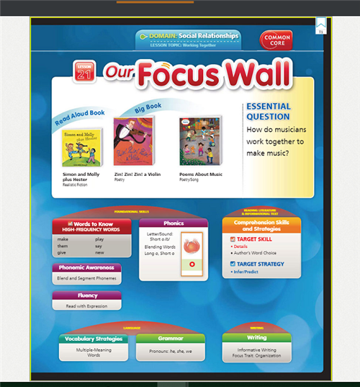
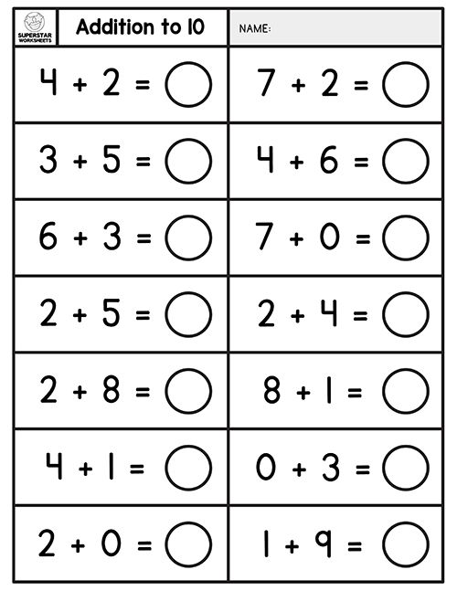

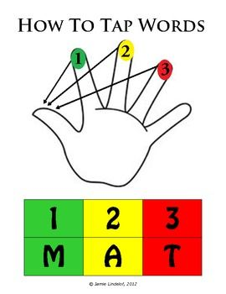

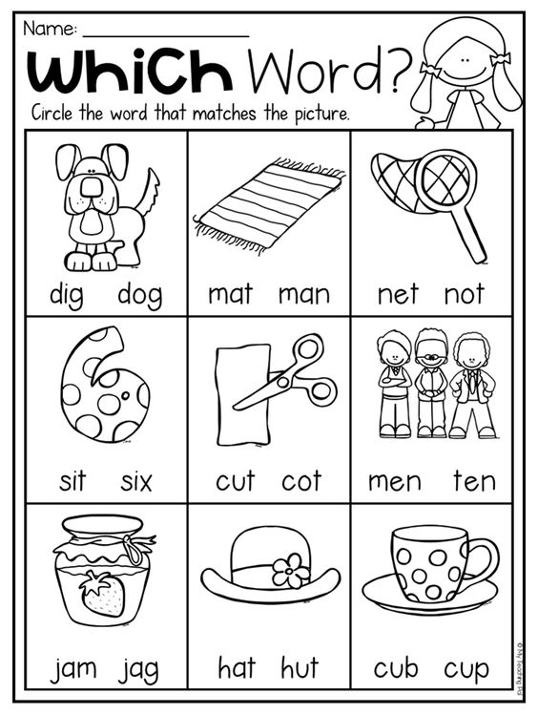

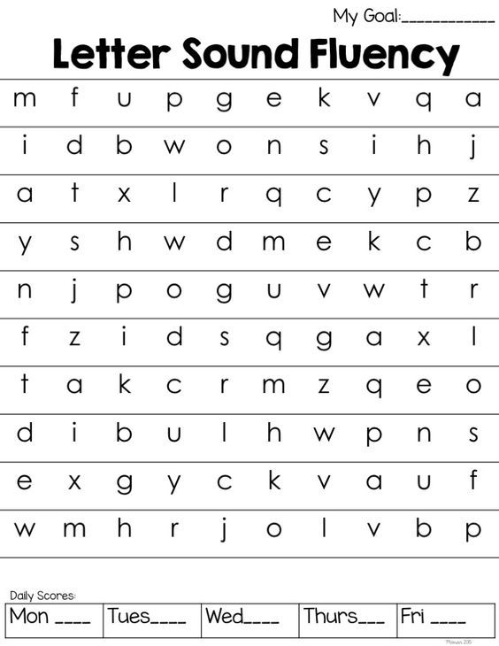
Practice tapping out & writing CVC words: (Focus- short /o/ sound)

- COT

- POT

- MOP

- ROT

- NOT

- TOP

